1. *A link to your GitHub repository for a NEW project* 
   1. <https://github.com/jv265/Part3PythonDockerFlask>
2. *a. The project showing that you can view* ***YOUR*** *data tables in pycharm*

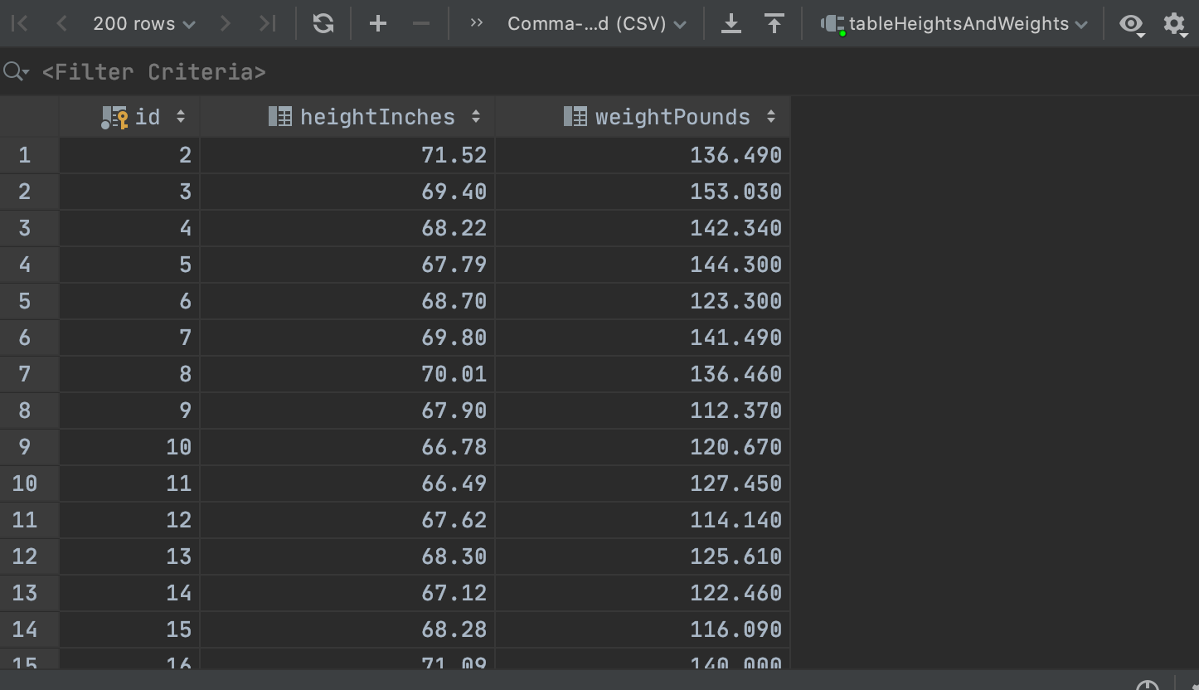

*b.* ***YOUR*** *project running correctly in the browser displaying your homepage with your data*

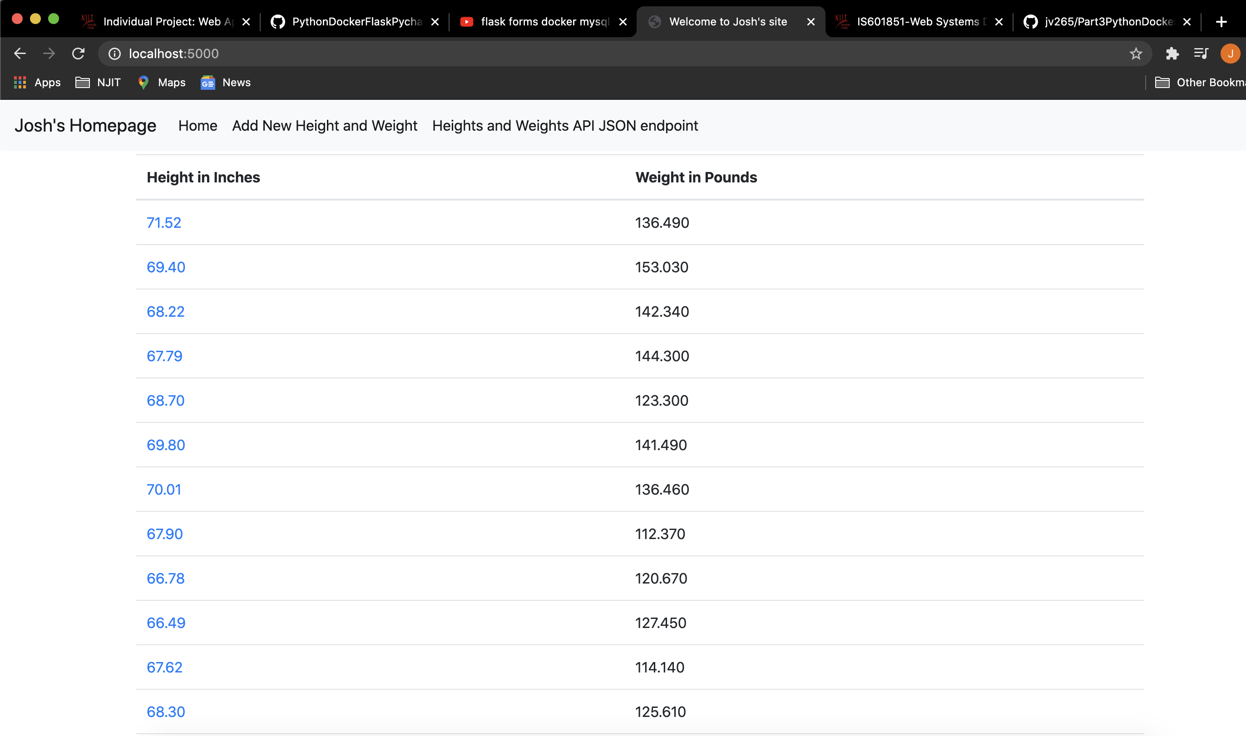

*c.* ***YOUR*** *project running correctly in the browser displaying your data record as a view of one record*

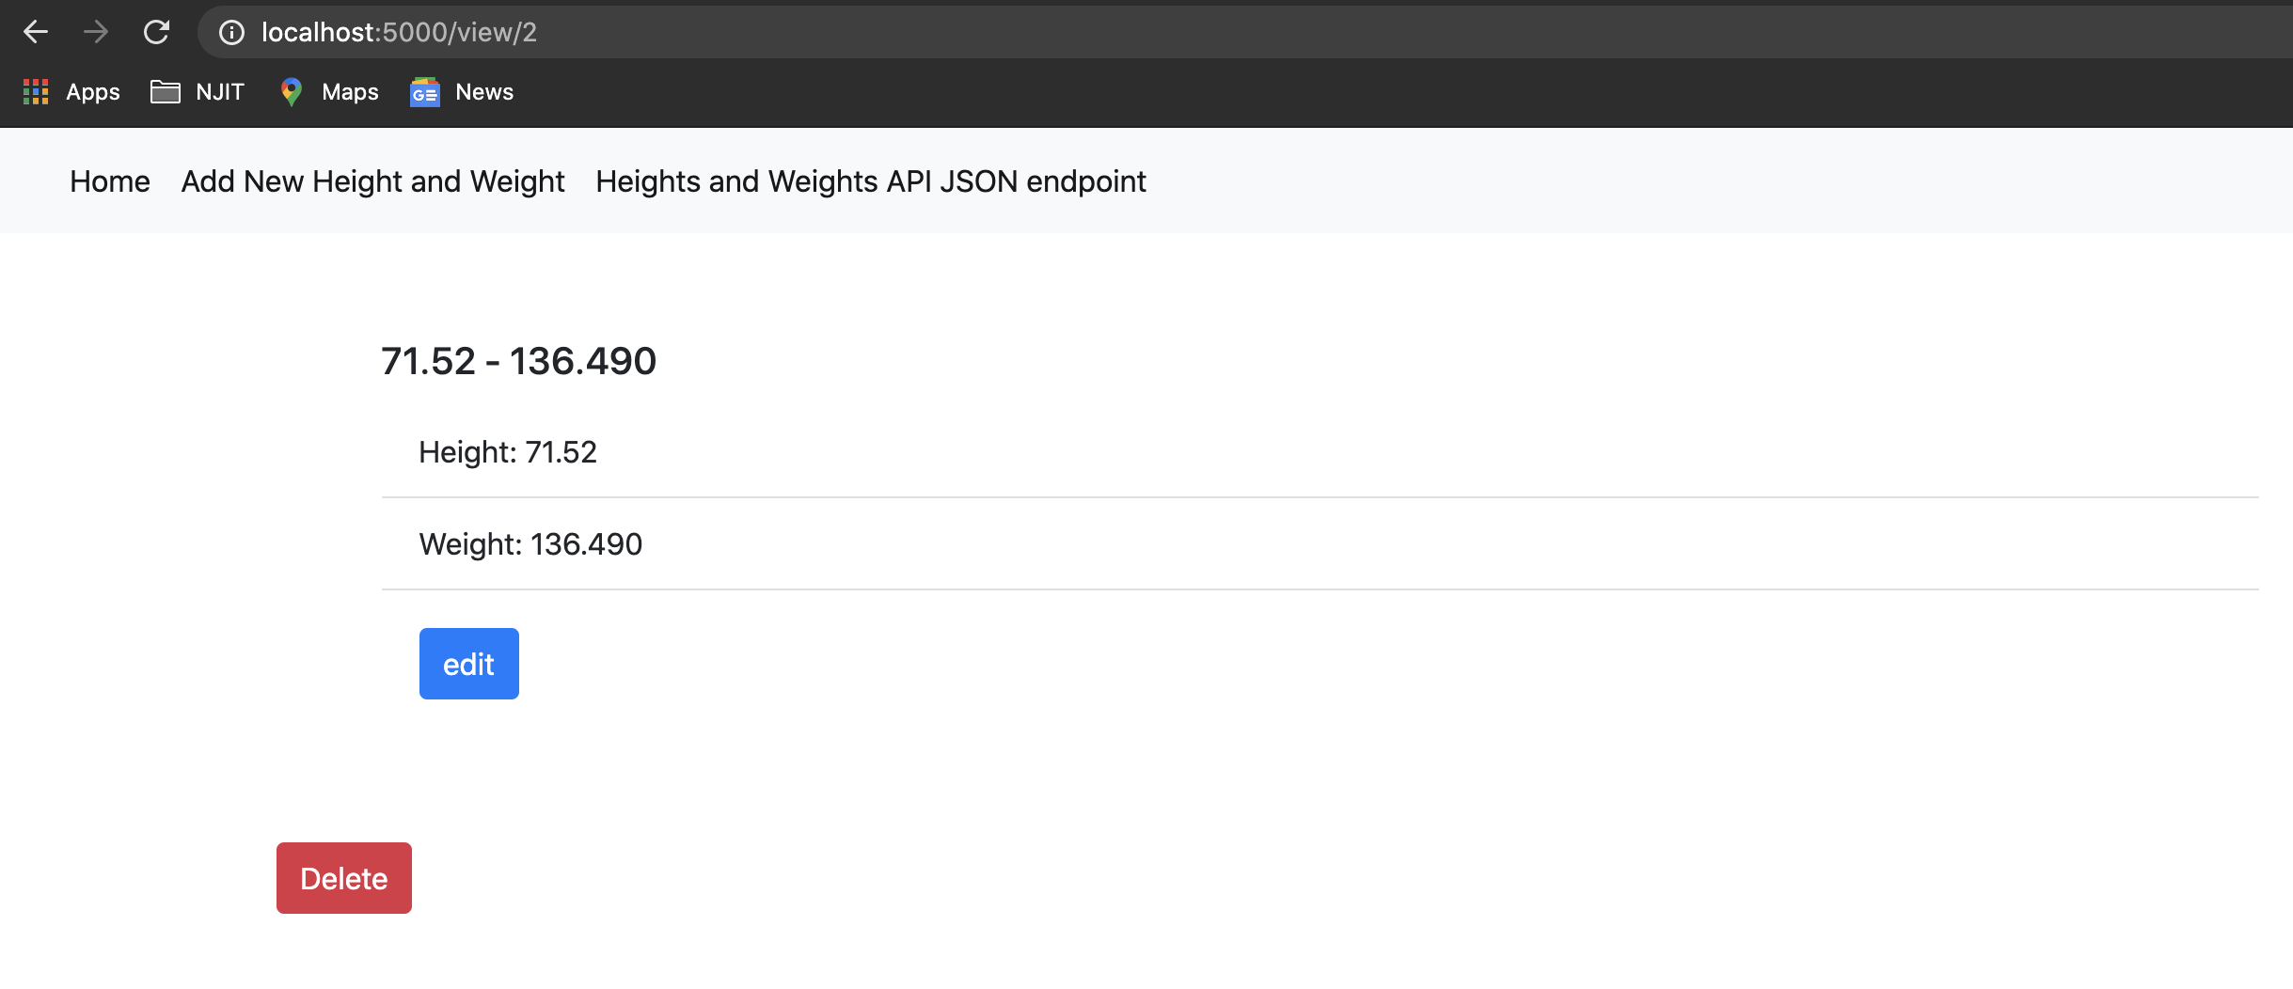

***Note: The first item’s id/index is 2 because I deleted items beforehand to test application.***

*d.* ***YOUR*** *project running correctly in the browser displaying a new record added to your home page*

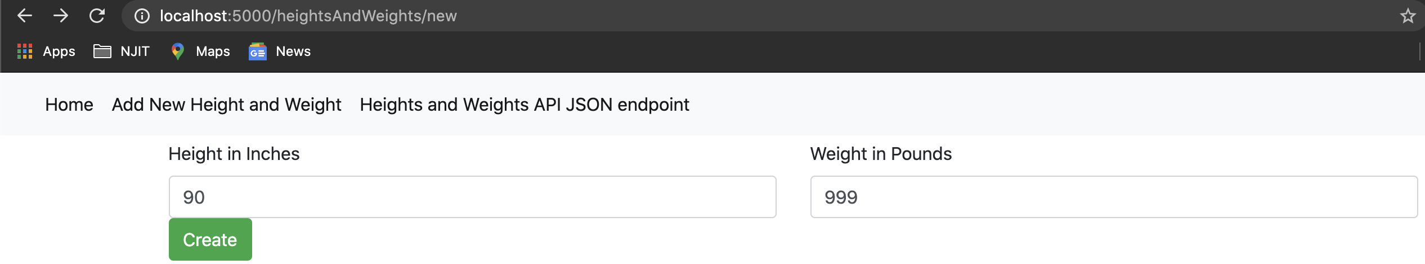

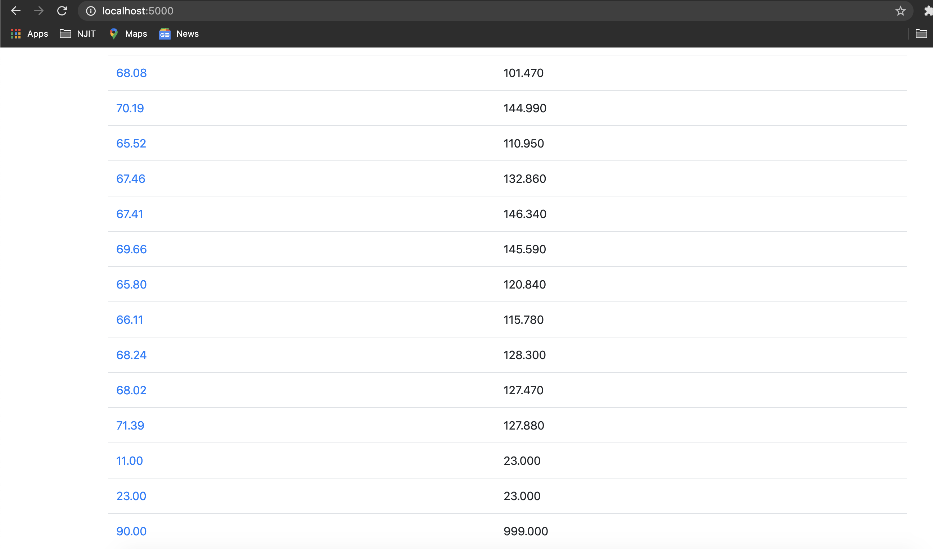

*Added Height: 90 and Weight: 999 to Bottom of List*

*e.* ***YOUR*** *project running correctly in the browser displaying an updated record added to your home page*

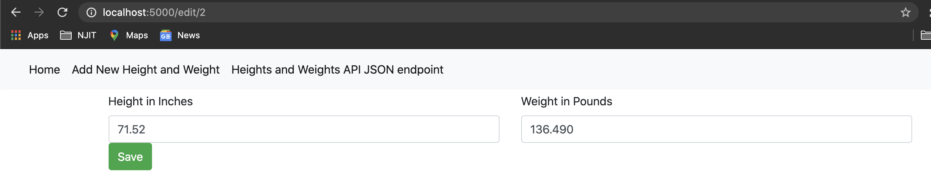

*Updated Fields as seen from Bottom picture*

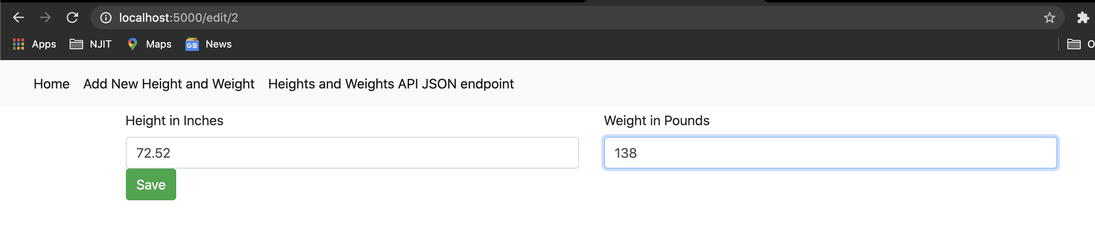

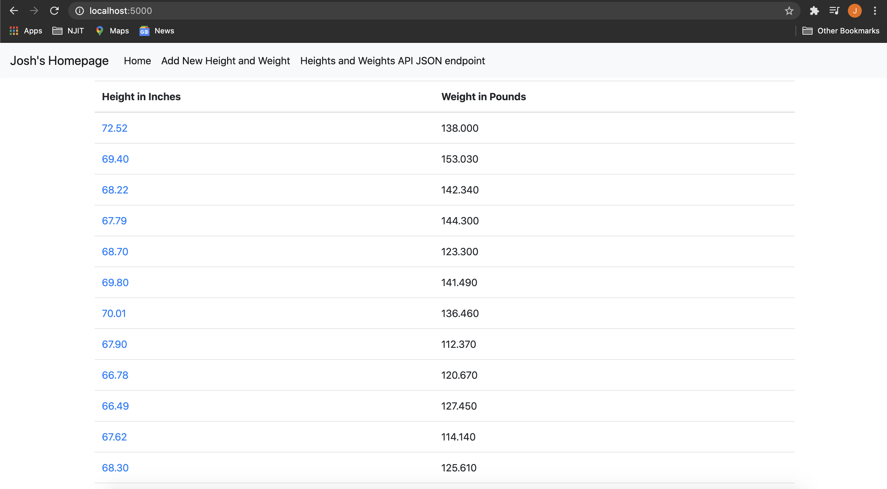

*Height and Weight was updated ^*

1. ***YOUR*** *project running correctly in the browser displaying a deleted record added to your home page*

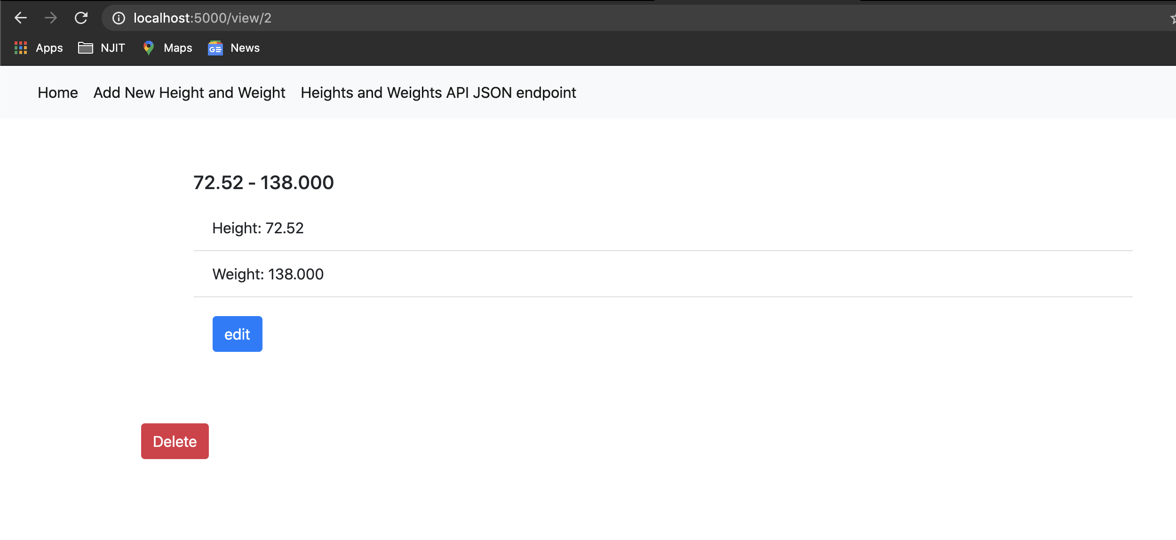

*Deleting Height: 72.52; Weight: 138.000*

